Chapter 4
Genesis 3
The Fall

As we have explained in the previous chapters, there is a huge gap in the two principal world views believed today. One of them is naturalism which has been enshrined by the Supreme Court and placed in our school systems and our colleges with most of our academic communities adhering to it. This worldview has everything in the universe coming out of nothing without God. The universe began with a big bang, emerging out of a black hole which the naturalists call a white hole event. The universe exploded out of the black hole about 13 or 14 billion years into what we have today. What we can see in the universe, 100-400 billion galaxies, each with 100 billion stars. It expanded from nothing and increased in complexity until there are these huge celestial systems-all strangely in largely stable orbits. These vast celestial systems of the whole universe are made out of atoms which we cannot create even in a laboratory and placed in stable orbits. In this naturalist world view, then over a billion years life arose from these same random atoms into the high life forms that we have, including mankind. And that is the story of naturalism. The whole material universe came out of nothing and then increased in complexity.

What we presented in the section on Genesis 1 and 2, was another story, completely different. The biblical account in Genesis was not over billions of years. In fact the creation of all the universe and life began in a very short amount of time, six days of 24 hours. The biblical account of Creation was not in the same sequence as the cosmological and biological view that naturalism claims. The chronological sequence is not the same in both world views. The creation of the universe and life took place a very short time ago according to the Scriptures.

There is one other very interesting consideration of the Genesis account-the nature of this Creator. Not much is given to us concerning His character from Genesis 1. However, if the book of John in the New Testament gives us a lot more detail about God’s character. The first of the book of John equates this Creator of the whole universe with Christ himself saying that nothing in the universe was created that He (Christ) did not create. Christ was in the beginning with God and that He was in fact God. Then John in the rest of his book shows certain miracles done by Christ which John personally had seen, showing His power as the Creator. Jesus Christ the man that walked the Earth was indeed the Creator Himself. Christ’s miracles in the book of John were violations of our laws of nature. He created things out of nothing such as feeding five thousand people with two fishes and five loaves of bread, accumulating 12 baskets left over after feeding 5 thousand people. He walked on water and we know that the flotation in the soles of a person's foot is not sufficient to do that, especially in a storm. Jesus brought back people from the dead. He made a man see who was blind from birth. He turned water into wine. All of these miracles are only acts that God could do.

But let us consider again Genesis 1 and 2. We can glean some other interesting things there about the nature of the Creator Himself, besides His ability to create by speaking. After nearly every day of creating, He says everything was good and very good. However, when He is coming to the end of the creation in the sixth day, He says, "Let us make man in our image according to our likeness". Now, this statement is very interesting. The term for God in the Old Testament is “elohim.” This divine name is a plural noun; however, it generally takes a singular verb. Here in the very beginning of Genesis God in talking about the creation of man refers to Himself in the Hebrew language using plural verbs and plural pronouns, “us” and “our.” "Let us" and he uses the plural verb of “made.” God uses plural pronouns, "in our image," as the pattern for the creation of man. In other words, there is a plurality in the Godhead, according to God Himself. There is only one God but He refers to Himself as a plurality of persons. God is not talking to the angels here because the angels were not part of the creation process. Only God was.

So what is unique in the creation of man since man was created in the image of God? None of the rest of creation including the animals is created in the image of God. In Genesis 2, we also saw another interesting thing. After each day of creation God pronounces that the things created on that day are "good." But on the sixth day when man is created, God raised His appraisal of this sixth day as “very good.” However, after He finishes that creation process on the sixth day in Genesis 1, there is another account of the creation of man in Genesis 2. Some critics of the infallibility of the Scriptures would say, "Oh that just proves the bible is a bunch of stories and myths." Myoptically, that view of the Genesis account comes from the occidental mind and occidental literature. In the Western world we tell a story once and that is the end of the account.

However, in the ancient oriental mind and literature, that is not the way the literature of historical events was done. For instance even in other place in the Scriptures, the books of Kings and Samuel, recount as historical narratives the same events in Chronicles. The very same events appear as historical narratives in the books of Isaiah and Jeremiah. If that is not enough, some of the same historical events are recorded as poetic literature in the Psalms and as prophetic literature in the prophets. In extra-biblical archives, there are from their battle steeles (stone monuments) on which kings have descriptions of their battle victories, sometimes written only eighteen days afterwards. These ancient oriental monarchs recount the same battle victories three or more times. In the New Testament the gospels recounts the life of Christ four times.

In the case of two accounts of the creation of man in Genesis 1 and Genesis 2, we have more detail in the second account. Both of these Genesis accounts are historical narratives, they are not poetic. The creation account is given in a poetic account in Psalms 104. But in this second account in Genesis 2 God says, "It is not good." Before He said everything is good at the end of the sixth day of Genesis 1 since He is not finished yet in Genesis 2, God says that it is not good that man should be alone. "I will make a helper for him," and then God created all the animals and brought them to Adam so that he could name them. But He further concludes for Adam there was not found a helper comparable for him among the animals. So the Lord God caused a deep sleep to fall on Adam. As Adam slept, He took one of his ribs and closed up the flesh. From the rib which the Lord God had taken from the man He made a woman and He brought her to Adam. Upon seeing the woman, Adam said, “This is now bone of my bone, this is flesh of my flesh, she shall be called woman because she was taken out of man.” Therefore, a man shall leave his father and mother and be joined with his wife and they shall become one flesh.

Why is it that God saw it necessary to make man two parts? Why was it that he uses the plural of Himself when He first talks about this creation of man, "Let us make man in our image?" Because in the God head (it is a mystery that we do not understand much of) there is the trinity in three persons. God made man as a plurality of two persons. Mankind was created very good as two equal persons at the beginning. So there might be what? A fellowship of two persons. Man was not to be alone as a singular being with the animals. Man was created as a plurality of two persons in fellowship as a reflection of the nature of the triune God. Evidently in eternity past, in this triune God, the three persons of the trinity were not alone. They are one God in perfect harmony and fellowship. This same plurality in mankind was evidently intended at creation of man as man and woman in the image of God as “very good.” This divine plurality, this divine fellowship, this divine working together in harmony was intended for man who was created in the image of God. Being of two parts, a man and a woman would come together to become one. And they produce what? In the end, they would procreate children as the third part. And the process would continue. That was probably God’s intent by creating man in His image, not to make man alone or mankind alone.

So at the end of the creation in Genesis in 1 and 2 at the end of the sixth day what happened? God quit creating after the sixth day. He rested the seventh day but it was not because He was tired. He had finished His very good creation. He was not worn out and there was nothing lost or depleted by God when He created the universe and gave it order. If any of us create things, the process takes away from us, we lose part of ourselves. It takes energy that we lose. There is a loss to us whenever we create things, or fabricate things, or make things. I know. I build big machines, and it takes a lot out of us. It eats up our machines, it eats up us, and days of our lives are gone and a lot of energy goes into it. But with God, He was the same at the end of creation. He was not worn out. He was not used up. And He was not degraded by creating the universe. Afterwards, He maintained this universe in Genesis 1 and 2 in the same perfect order. This Genesis creation account is the reverse of the naturalist’s storyline. The naturalists start with nothing and their universe builds up. And their universe becomes more ordered and complex. In Genesis, the universe is created with all its order and is perfect from its beginning. Then God maintains it after the creation. But, that is not going to be the situation forever.

The first law of science, the conservation of all matter and energy, started on the sixth day. From that day there have no new atoms, no new matter and no new energy in the universe. The universe has the same amount of matter and energy that it had on the sixth day. The first law of science is the conservation of matter and energy and it began on the sixth day. This first law continues until today because the universe can not create or destroy matter or energy. In this state the universe could have remained unchanged forever. The stars would never have burned out. Men would never have died. We would have lived forever in an eternal universe. However that was not to be.

It is important to review Genesis 1 and 2 as the basis of the first law of modern science. Matter and energy originated out of nothing during the creation events of Genesis 1. The first law of science, conservation of matter and energy, began on the sixth day. Not one gram of matter or one joule of energy has not been created or destroyed since the sixth day except for miracles such as during the life of Christ when He violated this law. The first law is the basis of most of our laws of science. In other words, all of our ideal conservation laws, which are most of our laws of science, come out of this law. The ideal gas laws, the gravitational laws, the electromagnetic laws, and optical laws are derived from this first law of science. All of these laws are what we call ideal laws. In addition to this first law of creation of matter and energy there is the second law of science which has to do with the order of matter and energy in the universe.

Th Genesis creation account is not an evolutionary old universe scenario. Genesis 1 & 2 described the exact opposite of the naturalist’s evolutionary universe story. In other words, God created matter and energy and then He fashioned it over 6 days into a very complex universe. The matter and energy in the universe was organized into order during the creation events recorded in Genesis 1 and 2. God maintained the perfect universe in perpetual motion state without decay and corruption after Genesis 1 and 2. Plants and animals had a perfect environment after the creation, with probably 100 times more species than today, living in a uniform, mild temperature over the whole earth during Genesis 1 and 2. The reason I say there was probably 100 times more species in the past as we know that from the geological record. Even the evolutionary biologists agree that the earth has lost about 99% of its species. Presently we are down to 1% of the species still living.

After the creation, the celestial bodies were visible immediately because the speed of light is nearly infinite in deep space. This comes from Maxwell's derivation that makes the speed of light as a function of the strength of the electromagnetic fields. These electromagnetic fields come from the subatomic electric charges in matter from which the celestial bodies are formed. So as light approaches these celestial bodies, its speed will slow down to the speed of light that Einstein enshrined as being uniform all over the universe. Contrary to Einstein’s assertion that the speed of light is constant throughout the universe, the speed of light in deep space will approach nearly infinite speeds where the deep space electromagnetic medium becomes very weak. The electromagnetic fields coming from the electric charges in distant celestial bodies will approach zero and the speed of light will approach infinity. As a consequence, Adam and Eve in the first days after creation could see all the six thousand stars we can see today with the naked eyes. Today, we can see deep into the universe with our most powerful telescopes. These powerful telescopes can see no end to the universe such as the deep field shots from the Hubble telescope. Because of the nearly infinite speed of light, today we can see today a very short time after the creation the light of the most distant galaxies. Assuming Einstein’s much slower speed of light, the naturalists would say that it took light 14 billion light years to travel from these distant galaxies. According to Maxwell’s derivation it probably takes only a very short number of years in the almost non-existent electromagnetic medium of deep space.

Consider some characteristics of the Creation drawn from Genesis 1 and 2. There is a creation order. The first day is the creation of light. On the second day of creation there is a division between the waters above and the waters below by a firmament in between. On the third day, the waters below are divided into dry lands and the seas with the plant kingdom placed on the land. On the fourth day, the sun, moon and stars are created to fill up the light realm of the first day. On the fifth day, the sea animals to fill up the sea and the birds and to fly across the firmament are created to fill up the waters below and the firmament of the second day. On the sixth day, the land animals and man are created to occupy the dry land created with plant kingdom on the third day. Perfect creation by God is the declaration is that it is "good" and "very good". In the Genesis creation, the universe is not going from chaos to order after the final day of creation. The universe at sixth day of creation begins with perfect order.

The waters above are divided by the firmament from the waters below which was then divided between dry lands and the sea. Above the firmament there are the waters above that would create a water canopy, probably water vapor. This “waters above” canopy would create an ideal worldwide climate which is seen worldwide in all index fossils of our geological layers. All the index fossils of every geological layer except the very last one, the Pleistocene (the Ice Age) indicate that there were uniform temperatures over the whole earth. These fossils show that plants and animals lived in a uniform temperature that was very mild in the Antarctica, the equator or the Arctic regions. The earth once had a uniform, moderate climate worldwide. Distant celestial bodies in a young universe would be visible through this very transparent water canopy surrounding the earth.

Lastly, the plants and animals were according to their kind in Genesis 1. This creates a genetic wall of separation and protection between the species. That protects the survivability of all of the species. If the different species can mix their distinctive characteristics on which their survival depends, then very shortly they would lose these characteristics fitted for their survival and they would die. Each species has very specific characteristics genetically wired into them, necessary for them survive in a specific habitat. If they could cross over the genetic walls of separation, there would be a continuum of species of mixed characteristics and every living being would die because it would no longer be able to adapt to its environment. Also, this genetic wall of separation between species would prevent Darwinian evolution from taking place. With asexual reproduction, the genetic specificity of survival characteristics dooms any genetic mutant from producing superior survival characteristics. The division of living beings into “kinds” creates an impenetrable wall of separation in sexual reproduction. A genetic mutant can not mate sexually with a member of another species to produce offspring into order to perpetuate its mutant form. There would have to be a male and female of the same mutation. These male and female mutants have: (1) to be of mating age, (2) to occur at the same time, (3) to be at the same place on the earth, and (4) to mate. By creating things according to their kinds, God eliminated Darwinian evolution.

The Garden of Eden was the perfect life for man with the tree of life but that best all possible worlds was lost in Genesis 3. In the world before Genesis 3, there was no rain on the earth, a mist watered the earth. In fact, there was no rainfall before the Flood of Noah in Genesis 6-9. Man was given dominion over the natural realm. Man named the animals and has dominion over them. There was no claw and tooth environment in which animals eat each other and kill each other to survive as we have today. Marriage of one man and one woman were created by God. He did not create two men for fellowship and he did not create two women in His image. But He created a man and a woman in His image so they can have that perfect harmony that exists in the God head. Food was vegetarian before the Flood. The carnivores came after the Flood. All carnivores are omnivores, they can live on vegetation. Life on earth from the original creation was perfect before the Flood and before the Fall. There was no fear of man and animals before the Flood but that all changed after the Flood later.
The Lord God took man and put him in the Garden of Eden. This is in Genesis 2:15, but there is a divine warning in Genesis 2:17 "But of the tree of knowledge of good and evil, you shall not eat, for in the day that you eat of it, you shall surely die." There is only one prohibition, one act of obedience, do not eat of this tree. You can eat of any other tree. You can do anything you want to do here. You can be a gardener. You can enjoy life. Adam and Eve had a perfect relationship with God because they could talk with Him face to face. They could walk and talk with Him. This is going to be the last time that that will be possible until the future eternal state.
"You shall surely die" was the warning. The temptation of woman, this is in Genesis 3, verse 1, "Now the serpent was more cunning than any beast of the field which the Lord God had made. And he said to the woman, "Has God indeed said, "You shall not eat of every tree of the garden?" And the woman said to the serpent, "We may eat of the fruit of the trees of the garden; but of the fruit of the tree which is in the midst of the garden, God has said, "You shall not eat of it, nor shall you touch it, lest you die." He didn't say you could not touch it, but there was probably a good reason not to get too close to the tree, but he says, "You shall surely die." That is what the woman told the serpent.

Then the serpent replied to the woman. The serpent by the way shows up later in Scriptures. Even in the future to us, the serpent is called that ancient serpent, satan or the devil. Satan possesses this creature, the snake, to speak. If you hear a speaking snake you know you need to be aware, but the woman did not realize it. By the way, Satan is the father of lies and he is a murderer from the beginning, that is what Jesus said about him. So he is going to lie to the woman and he is going to get her to die. Then the serpent said to the woman that she will not surely die and that is a lie. "For God knows that in the day you eat of it your eyes will be opened and you will be like God, knowing good and evil".

So the woman saw that (1) the tree was good for food (the lust of the flesh), (2) it was pleasant to the eyes (the lust of the eyes), and (3) it is desirable to make one wise (pride of life). Satan’s tricks have not changed. These temptations are exactly the same in the New Testament as John the Apostle warns in the first epistle of John: “For all that is in the world- the lust of the flesh, the lust of the eyes, and the pride of life-is not of the Father but is of the world.” I John 2: 16. Satan’s temptations never change.
"She took to the fruit and ate. She also gave to her husband with her and he ate. Then the eyes of both of them were open and they knew that they were naked and they sewed fig leaves together and made themselves coverings." Innocence is gone. The time of bliss and holiness is gone. They realize they are naked and they cover themselves with fig leaves. He took of the fruit and ate, she gave to her husband and he ate.

Then the Divine Inquiry begins, Genesis 3:8: "And they heard the sound of the Lord God walking in the garden in the cool of the day, and Adam and his wife hid themselves from the presence of the Lord God among the trees of the Garden.” Then the Lord called out to Adam because they'd met in the Garden and walked together before in the previous days, "and the Lord God called to Adam and said to him "where are you?" So he said, "I heard your voice in the garden and I was afraid because I was naked and I hid myself." Had Adam been afraid of the Lord before? No. Things had all changed. He is afraid of God. And he said, "Who told you that you were naked? Have you eaten from the tree of which I commanded you that you should not eat?" The man said, "The woman whom you gave to be with me, she gave me of the tree and I ate." It is not Adam's fault, its God's fault because He gave him that woman. The buck passing part starts here. And the Lord said to the woman, "What is this you have done?" And the woman said, "The serpent deceived me and I ate." So, the buck passing continues. Adam does not want to accept responsibility for his actions so he blames God. Now the focus is on the woman, so He inquires the woman and the woman says it is the serpent’s fault. There is no response from the serpent to this and God does not inquire of him because he knows he is a liar and he is the one who has created the trouble.

Now the judgments begin with the serpent, so the Lord God said to the serpent, "Because you have done this, you are cursed more than all the cattle, and more than every beast of the field; and on your belly you should go, and you shall eat dust all the days of your life" Evidently the serpent was able to stand up. By the way I do not know if you have ever looked at a serpent, but serpents are some of the most beautiful looking animals. Their eyes and the movements are beautiful even today. Probably, serpents were more beautiful creatures in the past than today before they were forced down to crawl on their bellies. The only thing about the serpent that I never liked is that they never have any expression on their face. I don't know if you've ever noticed that. Because they are great beautiful animals, Satan chose the serpent for this temptation of Eve. But, as a consequence the serpent is going to crawl on its belly and it shall eat dust all the days of its life. And lastly, there is a prophecy against this Ancient Serpent in Genesis 3:15, "And I will put enmity (that means hostility) between you and the woman and between your seed and her seed. He shall bruise your head and you shall bruise his heel."

In this judgment, God has put in a prophecy of a great future hope through the Seed of the woman. Do you remember in the genealogies of Jesus Christ, in Luke 3, whom do the genealogies trace Jesus back to? To the seed of the woman. It says, the son of so-and-so, the son of so-and-so, the son of Abraham, the son of Adam, the son of God. However, this genealogy in Luke however do not come through men, they come through a woman, Mary by a virgin birth without a male father. The virgin birth of Jesus, the Seed of the woman, Mary, is a direct fulfillment of this prophecy. In this judgment in Genesis 3, there is a future hope for mankind and it will be a fatal judgment against Satan. "You'll bruise His heel but He will crush your head." Right at the very beginning of Genesis is the promised Messiah coming through the seed of the woman.

Everything has changed from that beautiful creation, it begins a time of sorrow for mortal mankind. God’s judgment is then on the woman: "And to the woman He said, I shall greatly multiply your sorrow and your conception; in pain you shall bring forth children; Your desire shall be for your husband and he shall rule over you." This was not the case before. Without this temptation and fall women probably would not bear children in pain and they would not be probably in subjection to their husbands. This judgment will be eliminated in the future. In the future people will not be married or will not be given in marriage. Women will not be under the rule of a husband, their desire will not be toward the man, and they will not bear children in pain. But, this is a judgment for this period of time until the glorious time to come.

God’s judgment on the Man: "Then to Adam he said, "because you have heeded the voice of your wife, and have eaten from the tree of which I commanded you, saying, ‘You shall not eat of it’: Cursed is the ground for your sake; in toil you shall eat of it all the days of your life (in other words, you're going to labor eking a living out of the ground) Both thorns and thistles it shall bring forth for you, and you shall eat the herb of the field." "And in the sweat of your face you shall eat bread, till you return to the ground, for out of it you were taken; for dust you are, and to dust you shall return." It is an epitaph that is often read at a grave site: dust to dust, ashes to ashes. That is the way we return. The judgment is placed on the man, because he bore the main responsibility, he did not have to listen to his wife, and he could have corrected the situation, but he did not. So, this is a judgment upon all humans since. The fortunate thing about this is that humans do not live forever. What would it be like if we had to live forever in a state of sin and rebellion, a revolt against God? That would be a worse condemnation than death. Death is really a blessing to us. And the fact that we have to work and sweat all the days of our life. I don't care how rich you are, someone's out there sweating for you or for someone else. Nothing comes about without work-there's no free lunch out there.

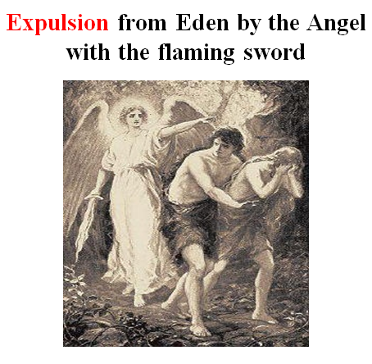

This is the beginning of original sin, and what it is its consequence since? The reign of death begins and it hasn't stopped to this very day. Only two people as far as we know have escaped this reign. Enoch before Noah and Elijah, the prophet, are the only ones that have not faced death. Even our Lord, Jesus, and all the apostles have faced it. All of us also will die, if the Lord does not return. It begins a reign of death that runs from that fateful day until this very day. Adam and Eve were expelled from the Garden and from God's presence. From this time on, they are not going to be able to look face-to-face to God, they are not going to be able to walk in the Garden with Him and enjoy the peace, and in fact they are even losing their home, the Garden. Adam called his wife's name Eve because she became the mother of all living. For Adam and his wife, the Lord made tunics of skin and clothed them. That is significant and it becomes very significant very soon. Their only atonement and covering for sin is from the death and the shedding of blood. God did it Himself probably in the sight of Adam and Eve, by killing animals and taking the skins of the animals to cover them. Atonement for sin can only be done by death. The term clothing or covering is the same word in Hebrew as atonement. Atonement does not eliminate the judgment of sins but is only a temporal 'covering' of the sins.

"Then the Lord God said, "Behold, the man has become like one of Us, to know good and evil." Who's God talking to when he says "Us" and uses plural pronouns here. It is within the persons of the God head-He's not talking to angels. He says that man become like "us" knowing good and evil now. "He says, And now lest he put forth his hand and take also of the tree of life and eat and live forever," Living forever by continuously eating from the tree of life would have been a terrible judgment. God is going to prevent that by pushing man out of the garden of Eden and the tree of life, "Therefore the Lord God sent him out of the Garden of Eden to till the ground from which he was taken". So, he drove out the man and placed cherubim at the east of the Garden of Eden. The cherubim (plural of cherub) have a flaming sword which turned every way to guard the way to the tree of life. In other words, outside of the original garden of Eden, He set up cherubim, very important angels with a sword so no one could back into the garden and eat of the tree of life and live forever. That garden of Eden does not exist today. It was very likely destroyed in the flood of Noah that took place later.

There are very serious consequences of original sin. The first-born man is a murderer. "Now Adam knew Eve his wife, and she conceived and bore Cain, and said, "I have acquired a man from the Lord," (the word "Cain" means to gain or acquire). Then she bore again, this time his brother Abel." "Now Abel was a keeper of sheep, but Cain was a tiller of the ground. And in the process of time it came to pass that Cain brought an offering of the fruit of the ground to the Lord. Abel also brought of the firstborn of his flock and of their fat. And the Lord respected Abel and his offering, but He did not respect Cain and his offering. And Cain was very angry and his countenance fell." Why would God not accept Cain's? Because Adam and Eve understood from the very beginning that the offerings were to be in blood. That is the only sufficient way the atonement is made and that things were acceptable to God and Adam and Eve would have taught their sons this. But Cain only had vegetables and he did not have animals to sacrifice. He could have traded with his brother, Abel, for animals. In rebellion Cain is insistent that God has to accept his offering of bloodless plants. But God would not accept Cain’s plants for sacrifice. Cain becomes very angry that God did not accept his sacrifice and "his countenance fell." "So the Lord said to Cain, 'Why are you angry? And why has your countenance fallen? If you do well, will you not be accepted?'" In other words do the right thing, just do it right. You know what it takes for atonement, what's acceptable to Me. "And if you do not do well, sin lies at the door. And its desire is for you, but you shall rule over it." But does Cain? No.

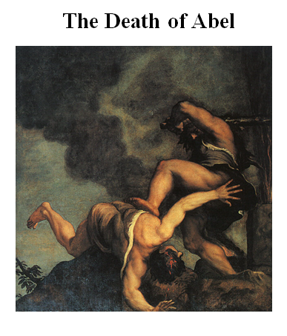

"Now Cain talked with Abel his brother; and it came to pass, when they were in the field, that Cain rose up against Abel his brother and killed him." Now what did his brother Abel do to him? Nothing. He's angry really at God. But he's going to kill his brother, because his sacrifice was acceptable. It is a long fall from the Garden of Eden in such a short amount of time, that the first-born man sins and kills his brother in the field. Divine judgment on Cain-Genesis 4:9, "Then the Lord said to Cain, 'Where is Abel your brother?' He said, 'I do not know. (but he knows) Am I my brother's keeper?' (that is a classic statement, sure he is his brother's keeper). And He said, 'What have you done? The voice of your brother's blood cries out at me from the ground.'" Blood is indelible. You remember even in Macbeth? "Out, out ____ spots"- people kill other people, shedding blood. But toward the end of their lives it becomes a nightmare, they can not get rid of the blood. And the blood stains that murder leaves, they are always there, you can not get rid of the blood stains. God makes them indelible.

To Cain, God says, "Where's your brother?" He says, "I don't know." He says, "Why does the blood of your brother cry out to me from the ground?" "Now shall be that you are cursed from the earth, which has opened its mouth to receive your brother's blood, from your hand. When you till the ground, it shall no longer yield its strength to you. A fugitive and a vagabond you shall be on the earth. And Cain said to the Lord, 'My punishment is greater than I can bear. Surely you have driven me out this day from the face of the ground." This is the first born man. "I shall be hidden from Your face; I shall be a fugitive and a vagabond on the earth, and it will happen that anyone who finds me will kill me." He feels like he will be open prey to anyone that wants to kill someone. "And the Lord said to him, 'Therefore, whoever kills Cain, vengeance shall be taken on him sevenfold.' The Lord graciously set a mark on Cain to protect him from being murdered. We don't know what the mark was, but it was very distinctive, so anyone wanting to kill Cain would see the mark and, knowing God’s curse, would not kill Cain. God is more gracious toward Cain than Cain was toward Abel, his brother.

Original sin: It not only affected mankind but this sin of Adam and Eve ruined the whole universe over which man was placed the keeper. The whole domain of nature was contaminated at this point by sin. The whole universe became subject to the second law of science, it was first defined in physics as the second law of thermodynamics, but today is simply called the second law because it applies to all matter-energy interaction in the universe. Einstein thought it was the most powerful law in physics because you do not even need empirical proof for this law. This law is a statistical law. When sin entered into the created material universe, God's relationship with the universe was broken. Romans 5 said, "by one man, sin entered the world, and death through sin." God's relationship and his maintenance of the stars, the galaxies, and all life as perpetual systems was finished. Did Adam and Eve die immediately? No. Did all the animals die immediately? No. Did the stars die? No. But the whole material universe begins to die, and this becomes known as the second law of science. Its Romans 8 explains this law of corruption and decay. For the creation was subjected when? In the past. What was creation subjected to? To futility. Not willingly because of God who subjected it in hope. This is what happened in Genesis 3 as Paul explains in Romans. However, the creation itself will be delivered in the future, from this bondage of corruption, the second law. At the present, the creation is groaning under this second law. The perfection that had been at the creation is now on its downward slide. The universe is worse every day than it was the day before. It will be worse tomorrow than it is today. The universe was subjected to the law of corruption in the past. It lives every day in this futility. In the future it will be delivered from this law, this curse.

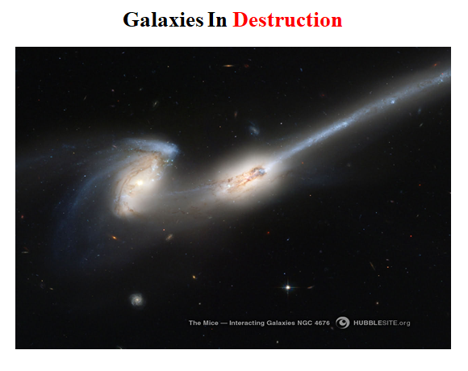

Here we see galaxies, these are two fairly large galaxies. They are in what you would call a "death dance" with gravity pulling between together them and tearing each other apart. Each galaxy probably has a hundred billion stars in it. One is slung by the other one, throwing out their stars into space to die there. They are twisting and they are shedding each other as they are tearing each other apart. They came too close in passing and under the pull of gravity they are spinning too fast, causing them to distort and fling their stars into space. The second law is at work here in a very big way as the two galaxies lose their stars and energy into deep space.

The second law is the law of increasing entropy (entropy is a big scientific term we use that just means disorder) which states that the matter and energy (the totality of the whole universe) always loses quality, that's order and usefulness, in every matter-energy interaction. Although the quantity of matter and energy, as we know from the first law, is always constant, the universe always loses order in matter and energy according to the second law. The first law is like an accountant, it always balances the books, it says you always have the same amount of matter and energy before and afterwards and matter-energy interaction. The second law, however, is the manager. It says yes, the quantity of matter and energy is always the same, but matter and energy always goes from states of order to disorder in the same interaction. The second law is true as Boltzmann developed, because there are more disordered states of any matter-energy system than ordered states.

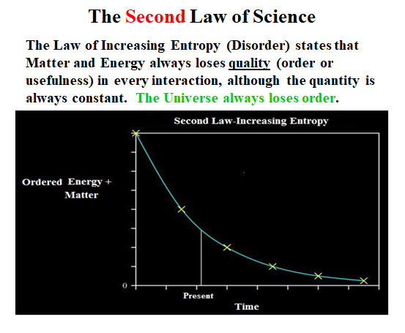

And if you plot this on time in this direction, ok and useful energy, you remember in the first law it was total energy and it was a straight line for all time, in this case its ordered energy and matter and its going down. In the future from the present time, the ordered energy approaches zero. The stars will all burn out. There will be total darkness and some physicists estimate that the ultimate temperature of the universe will be 4 degrees above absolute zero (zero degrees Kelvin). Deep space is presently fat 2.7 degrees above absolute zero and rising. As these stars all burn out and galaxies die, deep space will become an ocean of cosmic micro wave radiation only at 4 degrees above absolute zero. At 4 degrees there is, no light, and little motion of matter.

A simple example will explain the difference between these two laws, the first law and the second law. If you have a child and you have a calm, still pond of water, say a Walden pond, on a day with no wind. I do not know what it is about boys, but they love to disturb the serenity of a calm pond. Well, he picks up a rock and he throws it out into the pond. Right before the rock hits the surface, there is ordered, useful energy in that rock. If the rock’s energy was converted to electrical energy, it could run a toy electric powered car around for a long time. However, the rock hits the surface, sends out waves, and settles to the bottom. Eventually, the waves all die down. Well, from the first law, where did the rock’s energy go? The energy must be conserved to balance the energy books according to the first law. All of the energy goes into the waves of the pond, then the energy goes into the molecules of the pond water, and the temperature of the lake is slightly higher. Eventually, the molecules of the lake will give off its energy to the sky, and then to the universe where it will be spread all that energy in that rock throughout the universe. If only the first law were true, that lake could avenge itself. That energy in the molecules could come together, pick that rock up off the bottom and throw that rock back at the kid and avenge itself. And the first law would not be broken. However, the second law says, no that is not possible. It went from states of order to disorder, it can not go back the other way from disorder to order and avenge yourself, lake, you can not do it says the second law. I'm the manager.

So that is the difference between these two laws, a lot of people do not differentiate between the two laws. The universe will have in a thousand years from now the same energy it has today but the stars in the universe will give off a lot of their energy into deep space before they eventually reach their energy deaths. The whole universe, even though it contains the same amount of matter and energy (first law), is going downhill in ordered/useful energy and will eventually approach zero ordered/useful energy (second law).

Why is the second law true? It is just because of the fall of man in Genesis 3, "Cursed is the ground for your sake (he's talking about man)... In the sweat of your face you shall eat bread till you return to the ground, For out of it you were taken: For dust you are, and to dust you shall return." Romans 8 again, "For the creation itself was subjected to futility, not willingly, (did the universe want to be created and subjected to this law? No.) but because of Him (God) who subjected it in hope (hope for the future); because the creation itself also will be delivered from the bondage of corruption into the glorious liberty of the children of God. For we know that the whole creation groans and labors with birth pangs together until now." The second law is the law of the Fall and the curse, and it is tied to a historical event.

If you can picture in your mind, the first law, conservation of all the matter and energy, ends on the sixth day of Creation. The first law from which we get most of our laws of science is tied historical events, the Creation days in Genesis 1 and 2. The second law from which we get all the rest of our laws of science comes from which we get all the rest of our laws of science, comes from a historical event in Genesis 3, the Sin and Fall of Man. You know why that's so ironic? What part of scriptures do modern critics of the Scriptures laugh at as being historically and scientifically incorrect? Genesis 1-3. It has no valid history in the minds of the naturalists and it is scientifically absurd in their way of thinking. And yet, God has planted the laws that we get all of our science from in these three chapters and He ties the laws of science to historical events that they say are impossible to have taken place. You see the irony there? God is clever. And if people only understood Genesis, they could understand science. And we'll explain later in another session how important these two laws are and how powerful they are. And how, modern naturalism and our educational system is going backwards in its ability to solve problems because they have turned away from the knowledge of these laws. They have chaos in the way they teach science. You have to be a genius to get through the teaching of science today. But if you work with these laws, and knew them and where they come from, you can work miracles in the world of science. This second law comes from this historical event of the fall of man, and the breaking of God's relationship and maintenance of the universe.

Let us look though, to the future implications of this second law. I do not want you to dwell on this tragedy which we are caught into today. We are all going to die, unless the Lord returns. And everything is going from bad to worse. And all you have to do is read the news. What is the news made out of at 6 o'clock on television? It is death, destruction, tornadoes, people shooting each other as breaking news. What is death about if it is unnatural and newsworthy? It is the shedding of blood, almost invariably. It is a knife through someone or a bullet gun through someone or a death or injury in automobile accident or some other deadly event. That is what makes up our news, but let us not look to that, let us look to the future.

Release from the curse on Creation: The end of the second law of science in Romans 8:19. "For the earnest expectation of the Creation eagerly awaits for the revealing of the sons of God, because the Creation itself will also be delivered from the bondage of corruption into the glorious liberty of the children of God."
Destruction of the Present Universe: The present earth, heaven and earth will be destroyed by fire because it is contaminated with sin and it will have to be redone, this is in 2 Peter 3. 2 Peter 3:7, "But the heavens and the earth which are now preserved by the same word, are reserved for fire until the day of judgment." Verse 10, "But the day of the Lord will come like a thief in the night. In which the heavens will pass away with a great noise, and the elements (the very elements' atoms) will melt with fervent heat" Both the earth and the works that are in, will be burned up. The heavens, in verse 12, the heavens will be dissolved being on fire and the elements will burn with fervent heat. Both the earth and the works within will be burned up.

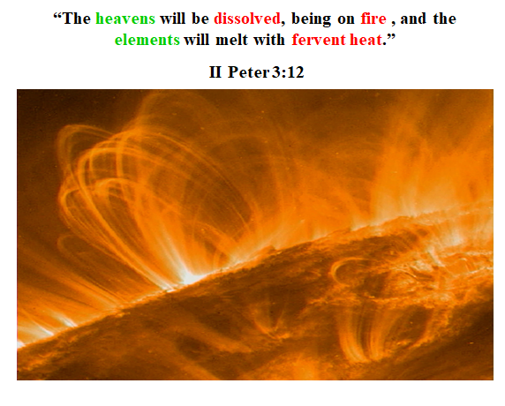

This picture of the sun is an illustration to what it will be like when the elements of the universe will burn with fervent heat. "The heavens will be dissolved, being on fire, and the elements will melt with fervent heat." The surface of the sun alone is about 6,000 degrees centigrade and the upper atmosphere of it is a million degrees. The matter in the universe is made of elements/atoms which have a nucleus made out of protons. Those protons want to blow the atom’s nucleus apart. They are pushing against each other with tremendous electrostatic forces. And physicists have theory which they call the "strong nuclear force" to hold nuclei of elements together. There is no experimental basis for the “strong nuclear force.” There is no source in matter that gives this strong nuclear force. We just know that something is keeping those protons from blowing the nuclei of elements apart. There is a possible answer in Scripture. It says, for instance, of Christ in Colossians, "in Him all things consist or are held together." What happens so that "the elements will burn, with fervent heat" when “the heavens will be dissolved.” When the force that holds the protons together in the nuclei of elements, there is a huge release of nuclear energy. A sudden release of nuclear energy leads to an atomic explosion such as an atomic bomb with tremendous heat. There is probably enough nuclear energy in the elements/atoms of each person to blow up the United States. That is how much nuclear energy there is in each one of us. It almost unimaginable what would happen if Christ who is holding all things together releases nuclear energy of all the elements of the whole universe in a future moment of time. As the passage in I Peter says, the elements would burn with fervent heat as the universe/heavens disintegrates into ultimate destruction.

In light of this fiery destruction of the universe, there is a call to holiness for believers in the present in anticipation of life in the new heavens and earth. This is also in Peter 3:11, "Therefore, since all these things (in other words, the whole natural realm) will be dissolved, what manner of persons ought you to be in holy conduct and godliness, looking for and hastening the coming of the day of God, because the heavens will be dissolved, being on fire, and because the heavens will melt with fervent heat." There exists a small example in the universe of elements being consumed with a fiery explosion. This is called a nova and they happen about every 2 or 3 days. It is a star blowing up. Supernovas are much less frequent being massive nuclear explosions of big stars or whole galaxies, seen largely outside of our Milky Way galaxy. On a small basis, these novae and supernovas show what will happen when the heavens (whole universe) will dissolve in fervent heat. But Peter asks, What manner of life are we to live in light of the fact that all we have is going up in fire? "Looking for and hastening the coming of the day of God, because the heavens will be dissolved, being on fire, and the elements will burn with fervent heat." He continues in verse 13, "we, according to His promise, look for new heavens and a new earth in which righteousness dwells." In other words, sin is done away with and we look for that. "Therefore, since all these things will be dissolved, what manner of persons ought you to be in holy conduct and godliness?"

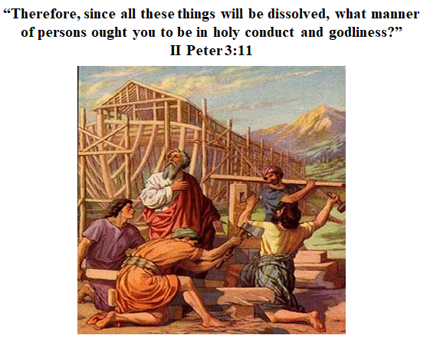

I chose a picture of the past. You know who this is? Noah! How long do you think it took him to build that boat, the Ark? It took over 100 years. Noah is called in the Scriptures, a preacher of righteousness. Did he warn the people ahead of what was coming? Yes. Did he lead a godly life? Yes. Was everyone else ungodly? Yes. Was God going to destroy the world? Sure He was. There were only going to be 8 people to survive what was coming. For 100 years Noah continued to live a godly life, preaching to all of the people, saying, "Change your ways, judgment lies ahead." In the same way, Peter uses Noah as an exact example of godly living and preaching. The unbelievers ignore what is coming ahead. But believers have this hope, Peter says, things going to change. In the mean time, in light of the future destruction of the material universe, Peter asks, why do you hold onto this material world? This material universe that you can put your hands on is disappearing. You will not take any of it past the grave with you, plus there will not be anything of this present universe left even if you came back from the dead. "What manner of persons ought you to be in holy conduct and godliness?"

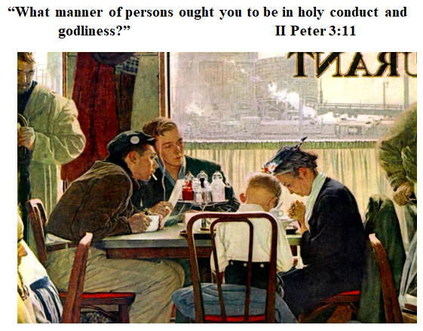

This is a Norman Rockwell, and look at this. This is a grandmother and her grandson, sitting there, praying, thanking the Lord for their food in a restaurant, across from two guys, who are curiously looking on. Did the guys pray for their food? No. They are puffing on their cigarettes, looking at the grandmother and her son. And look at this guy off to the side, he is looking at her too. But did it change her conduct, or her grandson's conduct? No, they are thanking God for their food. The others are not participating in their godly thanksgiving.

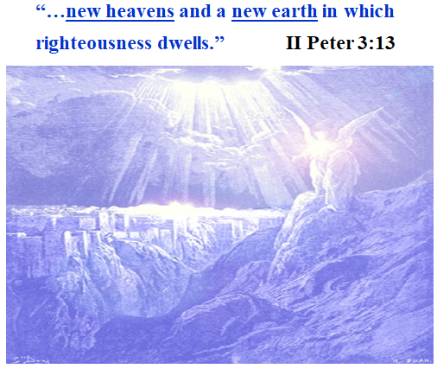

This is just an ancient drawing of what the new heavens and the new earth would be like.
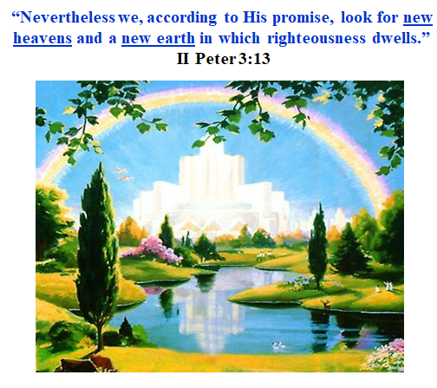

This is a more recent one. "Nevertheless we, according to His promise, look for new heavens and a new earth in which righteousness dwells." Returning to an even better situation than the Garden of Eden before.

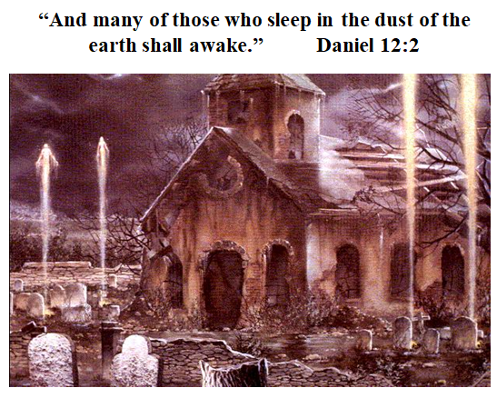

This goes back to Daniel 12, "And many who sleep in the dust of the earth shall awake" coming out of the tombs, as Old Testament saints did after the resurrection of Christ. At the death of Christ, when the veil of the temple was ripped, the tombs opened up, and then after his resurrection, the saints came out of the tombs and they walked around and were see by many (Matt. 27: 52-53). We already have cases in history of what the future resurrection of believers is going to be like. But Daniel says, in the future, those who sleep in the dust of the earth shall awake. "And many who sleep in the dust of the earth shall awake” To what? Some to everlasting life and some to shame and everlasting contempt. Everyone lives forever, we all come back. But it is not to the world we left, and it is not to the destinies we share here. "And many of those who sleep in the dust of the earth shall awake, some to everlasting life... some who are wise shall shine like the brightness of the firmament, and those who turn many to righteousness like the stars forever and forever."

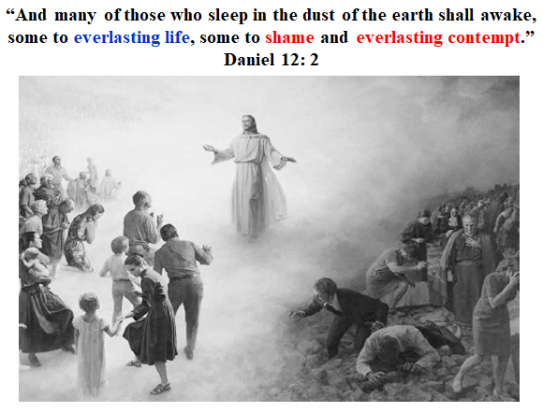

"I John," this is in the Revelations 22: 2, "saw the holy city, the New Jerusalem, coming out of heaven from God."

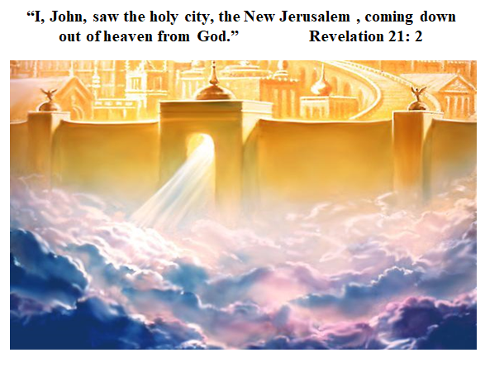

There is no more curse in the New Jerusalem, it is the end of the second law of science. Revelation 22: 3-5, "And there shall be no more curse, but the throne of God and of the Lamb shall be in it, and His servants shall serve Him." "They shall see His Face, and His name shall be on their foreheads." "There shall be no night there: They will need no lamp nor light of the sun, for the Lord God gives them light. And they shall reign forever and ever." "And there shall be no more curse, but the throne of God and of the Lamb shall be in it, and His servants shall serve Him."

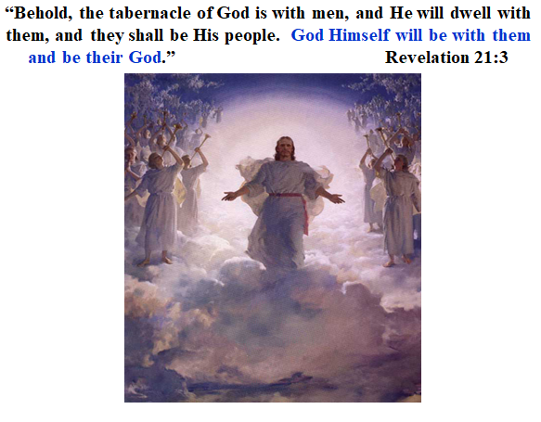

"Behold the tabernacle of God is with men, and He will dwell with them, and they shall be His people. God Himself will be with them and be their God." Believers will be returning to a personal relationship with God, much better than the Garden of Eden. It will be a walking and talking relationship with no barrier of sin.

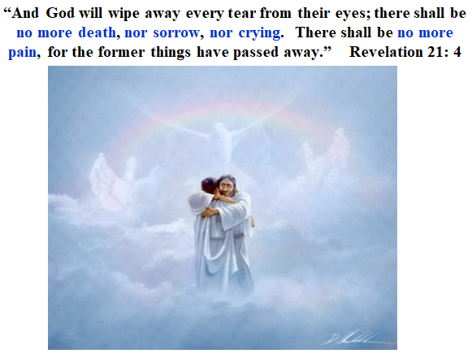

The love and care of the LORD will be very personal as Revelation 21:4 states, "And God will wipe away every tear from their eyes; there shall be no more death, nor sorrow, nor crying. There shall be no more pain, for the former things have passed away." Ten thousand years from now, will you remember the hardships and the bitterness and sorrows of this life? No, the Lord will make the former things remembered no more. The curse will be lifted and we will live forever in a paradise that God has prepared for us. As the Scriptures says, it has not entered the heart of man the things that God has prepared for those who love him.

