Chapter 5
Genesis 1-3
The Implications of the Laws of Science

A number of years ago, I hate to say how many but it was about over 30 years ago, I was on business in Washington D.C., I had a series of meetings there and I had an old friend there with whom I was staying. We had some conversations in the evening time. Although he is not a scientific type, we went over some of the laws of science, particularly the implications of the basic laws of physics. The next day, I had a break in my meetings which were near one of the major universities there in Washington. So, I went over the university campus to visit and during this time when my friend was working with some students. A little before lunch he disappeared for a while and upon his return he said, "I've got a luncheon appointment for us." And I said, "Well, that's nice."

Only, it was not for eating lunch. We went into one of the classrooms at the university. The classroom was a theater in the round type of lecture hall with only a hundred seats in it but it was empty. As we sat down in the front row, I said, "What's going on?" And he says, “I’ve got a man I want you to talk to, he'll be here shortly." Shortly thereafter, in the door comes this fellow, he must have been about 65 years old, probably closer to 70. My friend and I stood up and made our introductions with the fellow. It turns out that he was a physics professor and I have a feeling that he was the head of the physics department. This friend of mine had gone over and hustled him. We were going to have a little conversation instead of lunch. My friend said, "I want Mr. Penny to explain to you these scientific laws and some of the implications." My friend explained, "I don't know enough about the laws of physics but I wanted to have you who knows a lot about physics to examine these things and give me a critique." And I thought to myself, "Man, he is putting me into the cooker on this thing. This was no lunch- I was being served up for lunch."

So I began to explain the laws of physics before getting into their implications. There was a chalkboard and everything needed to make a good presentation. My friend and the professor sat there as I laid out the two basic laws of physics rather quickly. I did not want to act like I was treating this professor as a freshman in college. So I stepped fairly lively into the two basic laws with diagrams. After I had drawn up the two laws and superimposed them, all of a sudden this professor stood up and said, "I know where you're going with this." He said, "I don't like it." And he immediately walked out of the room. I had not even gotten to my conclusions yet. But this professor was a smart fellow. This friend of mine turned to me and said, "I can't believe this." At about this time, the door to the lecture hall opened up and this professor stepped in and he said, "You're going to force me to teach something I do not believe." And I said, "These are the most basic laws of physics and of science in general." And about that time, he says, "I'm not going to do that, you're not going to force me to teach things I don't believe in." And he slammed the door and walked out. I sat there kind of stunned, I had never had that kind of reception. And my friend said, "This is unbelievable." He said, "I thought you were just exaggerating on the importance of these two laws and their implications." I responded, "No, I mean, these two laws are well known but a lot of people have not connected the dots on them."

These two laws and their implications are what we are going to cover in this chapter. We are going to study these two basic laws that we have developed in the previous chapters and see what are their implications concerning the origins of the universe. We are not going to get into the origins of life at this point. What we have here is the question that was raised previously, "Are we looking at the whole universe as a cosmic accident or is the universe a divine creation? Naturalism would teach us to believe that we're looking at a cosmic accident in time and space. The Scriptures present: No, this is a creation, this is a product of a divine, supernatural agent, God. This biblical creationism is what you have in contradistinction to naturalism. These are two contradictory histories of the universe and of life. However, history is matter and energy interactions occurring in the past. And the one thing that you know about history and especially about physics is that the past events of matter and energy are fixed in time. They as historical events are not subject to revision. No one can go back in time and rewrite them. The past is the past and those events took place in a certain sequence. Not what I think about them nor what anyone thinks about them will change them. The events of the past are fixed and they are written in the stones of time. No one will change them or erase them.

So when we look at history, when you say naturalism has its story and biblical creationism has its story, only one of them is the truth or neither of them are the truth, but something did take place in an immutable sequence of past events. And what you and I think about them is not going to change that. Creation by God of the universe and life in six days, less than ten thousand years ago are recorded in Genesis 1-3. It is in stark contrast to naturalism's origins of the universe billions of years ago with life beginning about a billion years ago. Immutable history did not allow for both Genesis 1-3 creation and naturalism to be true. They can not both be true about the origins of the universe and life.

Let me take you down through some of the contrasts that are very sharp between these two stories of the past. In biblical creationism, you have a universe created by God. In naturalism, you have a Godless universe-there is no God, it all happened by time and chance and the universe arose out of nothing. In biblical creation, you have a creation less than seven thousand years ago. In naturalism, you have a universe that began billions of years ago. In biblical creationism, you have God created the universe from nothing. In naturalism, you have the universe also from nothing but from a singularity point smaller than a single atom. The whole universe came out of that singularity point in time and space. Before that, there was nothing. In biblical creationism, you have a universe created in six days. In naturalism, you have the universe exploding into being billions of years old from a reverse black hole event. In other words, black holes as they teach have such strong gravity that everything disappears into the. Black holes suck up matter like a giant vacuum cleaner. In the contemporary view of Big Bang theory the universe exploded with such force that it came out of a black hole (singularity point) in a reverse black hole event. And the universe is still expanding out of that black hole. That is why Einstein and others feel that the universe is finite. The universe can not be infinite if it came from a singularity point in time and space.

The contrast between creationism and naturalism is very sharp. There are more contrasts between biblical creationism and naturalism. Biblical creationism would say the universe and life were created complete, perfect in order at the very beginning. Naturalism teaches that the universe began with no matter, no life, no energy and no complexity. In biblical creationism, the universe and life began perfect and then began to die into disorder. The reverse of that is true in naturalism, the universe began disordered and became more complex with time. In naturalism’s story, the formation of celestial systems, solar systems, galaxies and everything became more complex. Naturalism’s life story is the same way. Life started off with random atoms and became more complex in time. Creationism and naturalism are reverses of each other. One starts perfect and goes to disorder, the other one starts with disorder and comes to high levels of complexity.

Biblical creationism teaches that the laws of science were determined by God at historical events. We saw those in Genesis 1 and 2 where the first law of science, conservation of matter and energy came into existence. On the sixth day of creation, the universe was finished-nothing has been created since then. Today, we have the same number of atoms, the same amount of matter in the universe and the same amount of energy that we had a thousand years ago or that we will have a thousand years from now. In any matter-energy event, the universe never creates or destroys any matter or energy. The first law began at the history event of creation. Also, we have the second law which came about when the relationship between God and his creation was broken and the universe began to disintegrate. Today the universe has the same amount of matter and energy as it had at creation but the universe’s matter and energy is constantly becoming disordered since the historical events of Genesis 3. The second law came about by the fall of man, the judgment of God, and God not continuing to maintain the order in the material universe because of man’s sin.

In naturalism, the laws of science just happened by chance. Why is the first law true? Oh it just happened, the naturalist would say. Why is the second law true? Oh it just happened, after the Big Bang, a naturalist would state. There is no rhyme nor reason to the origin of the laws of science. There no explanation in naturalism for the origins of the laws of science. In biblical creationism, all physical phenomena is controlled by rational laws of science that God has ordained. He fixed the laws of science so matter-energy interactions always produce the same results. For instance, take a bird and it lands on a branch. The bird never had any courses in aerodynamics. The bird has no runways to take off from and to land on. And yet it lands, generally in stall conditions, following exact laws of aerodynamics. How does it do that? How did it learn the complexities of aerodynamics? The bird is following laws which even some of our most sophisticated rocket scientists do not understand.

As we pointed out previously, beginning in the 1500's men begin to understand that these physical events do not happen capriciously and randomly. The wind does not blow because there is a god of the wind, or the sea does not get stirred up because Neptune started it and created a storm. God created rational laws at historical events to run the universe. If those laws were constantly changing, would that bird be able to land? No. He would crash into the branches if any bit of the laws of physics changed. Although the physics of aerodynamics can be very complex, the laws controlling aerodynamics are immutable. Flight is very complex with birds because they are changing their air foils, they use their wings for repulsion as well as lift, and they come in and take off in stall conditions. But fortunately for the bird, God has established the laws of science so that the universe always does the same thing in the same conditions.

God’s rational laws of nature are never violated except in the case of miracles where God intervenes. This can be seen in the case of Christ when he walked the face of the earth. Christ broke these laws of physics to show that he has the power over nature as the creator and the future savior of the universe. In naturalism, all physical phenomena must have atheistic explanations. The naturalists do not understand where the laws of science came from or why the laws are what they are. Some naturalists do not always think that the laws of science are consistent and rational. For example, in quantum physics the naturalistic physicists think that there is no universe out there unless there is a mind to observe the universe. Matter/energy event in quantum physics do not happen by exact laws. Events happen randomly, like playing dice at a casino. Albert Einstein would not accept quantum physics because he said that God does not play dice with the universe.

In biblical creationism, the universe in the future will be destroyed and replaced by a new heavens and earth. This will take place before all the stars burn out and the galaxies in the whole universe die. In naturalism, most naturalists believe that the universe is eternal and continues forever. In biblical creationism, life was created by God in 6 days, less than 7000 years ago, in a complete order, including man. According to naturalism, life arose by evolution by time and chance, starting with disordered things and rising to the order of human beings. Humans are naturalism’s end product of this evolutionary process of random mutations chosen by natural selection. Natural selection does not produce any better mutations but it keeps bad mutations from taking the evolutionary process back to more disordered life.

In biblical creationism, God has eternal purposes for the universe and for life. In naturalism, there is absolutely no purpose for life or the universe-the universe and life are a cosmic accident. There is no design or order for why the universe and life are taking place. And the universe and life have no purpose. In biblical creationism, life on the earth has a unique place in the universe. In naturalism, life on the earth is not unique at all. There are probably billions of other civilizations like ours somewhere out there. The whole purpose of SETI, the Search for Extra-Terrestrial Intelligence, into which the government has pumped tens of millions of dollars, is to listening for some signal that indicates there is evolved life out there in the universe. To the naturalist, life is not unique here on the earth. And we as individuals are not unique. In naturalism, none of us are unique, the world we live in is not unique, and the universe is not unique.

Biblical creation makes certain assertions. One, God created the Universe ex nihilio, that is out of nothing, and formed life on earth supernaturally less than 7,000 years ago. Two, God established the laws of science but interacts with the universe through miracles. In other words, He occasionally intervenes for whatever His purposes are and He violates the laws. But normally the universe runs according to these laws that he's established from the beginning. For instance, on the sun there is nuclear fusion. Nuclear fusion was taking place on the sun before man every discovered it. Did it start the day we discovered nuclear fission? Of course not! Do we have someone that is up there tuning the sun, to make sure it does get too hot or too cool. "Well, it is getting a little too cool today, can you turn the heat up?” Or, “Oh the temperature's getting a little too high, we've got to turn the heat down a little lower." Even your body's got a million functions, autocorrelation functions that determine what your temperature is, when you need water, when your body needs to go to sleep. And, you can walk along carefree not even thinking of any of those things. Why? Because God set your complex bodily functions in order so that they operate without you even having to think about it. Three, God judged the universe because of man's sin in the past, in three events: (1) the curse at the beginning with Adam and Eve which affected the whole universe, (2) the worldwide flood that we'll see later in the flood of Noah, changing the whole face of the earth and eliminating everything that lived on land at that period of time, and (3) a division of mankind into languages and races. We didn't evolve by different races, we devolved into many. And also, our languages are not a product of evolutionary process. They're more complex at the beginning and they're degrading. Four, God will destroy the present heavens and earth and establish another eternal heavens and earth that will be without sin or corruption or decay, the universe will never grow old. Fifth and lastly, God gives eternal life to believers in Jesus Christ, who is also the only one that's walked the earth that is perfect, who is the only one who has ever been a creator.

Let us look at academia's assertion which is naturalism. Academia’s assertion is that naturalism is science. "The cosmos is all that is or ever was, or will ever be." This is a classic statement from Carl Sagan. He's now dead but he was a Harvard professor when I was in school. He was a pop science guru for the TV science series 'Cosmos' which occasionally has reruns. Sagan sums up naturalism-what you see is what you got. That is all there is and will ever be. If you can't touch, feel it, or hear it, or taste it, then it doesn't exist. In naturalism, there is nothing outside of the matter and energy that you experience and interact with. Naturalism is the basis of public education and court's decisions. Naturalism, by definition, is the mode of thought (religious, moral or philosophical) glorifying nature and excluding any supernatural or spiritual elements. It does not allow for anything but matter and energy and things you can interact with your senses. Our public educational system teaches fraudulently that naturalism, the exclusion of any supernaturalism (such as God or creation, angels, heaven or hell), is scientific truth. It is fundamental to naturalism that there are no scientific proofs of the supernatural, such as God, creation, heaven or hell at the present time. By the way, that is correct. There is no experiment that you can do at the present time to prove the existence of God or angels or anything else supernatural.

However as we shall see, the extension back in time that there are no experimental proofs of supernaturalism is totally false from the laws of science. Using this false claim that there is no scientific proof of the supernatural, naturalistic academia claims an exclusive right to science. Academia indoctrinates its students on a world wide basis. In academia naturalism is science and supernaturalism is religion. To the academician there is no intermediate ground. The products of this public educational indoctrination are law students, lawyers, and judges who legally protect the indoctrination process with the judicial system. Judges use the guise of separation of church and state to enforce this educational indoctrination by their legal decisions. The judges say in their cases: if it is supernatural, then it is religion, but if its naturalism, which is basically atheism, then it is science. I have listened to the judges that have rendered some of these pivotal decisions. Hardly any of them know anything about science. They are solely products of their educational system. They have been indoctrinated this propaganda all of their lives. Naturalism, the exclusion of supernaturalism, such as God, creation, angels, heaven, hell, is in reality, atheism, by definition. The mandating of naturalism in our school systems and our courts, is the establishment of atheism, by the Supreme Court as the state religion. The educational institutions can only teach naturalism by courts’ decrees.

Let us look at the two basic laws of science and get into their implications. The natural universe has only two components: matter and energy. Matter is a substance of the universe and energy has no matter effects. Energy is the thing that holds matter together and gives matter energy to move and interact. As you drop the temperature down to absolute zero temperature, matter becomes motionless. There is no free energy at absolute zero. As you come up in temperature from absolute zero degrees, then energy starts matter into motion, moving back and forth and creating electromagnetic radiation. So matter and energy are only two things that occupy the material universe that we look at. The two most basic laws of science define every interaction of matter and energy: One is the quality law, the conservation of matter and energy. The second law in every matter-energy interaction is the law of increasing entropy or disorder of matter and energy.

When I was a student at MIT, I had come out at the time that our government was very much panicked after Sputnik. The Russians put Sputnik it orbit, and our government became very concerned and everyone else because, if they could put satellites in orbit over us, they could drop bombs on us. It was the beginning of ICBM's, Intercontinental Ballistic Missiles. Everyone started building bomb shelters in their backyards and public buildings. They started storing up food and building shelters that would survive a nuclear blast. The US government also tested all of the junior high and high school students in the United States to find out who were the best students in math and science. The government supplied free government science and math summer camps for students who passed high on these exams. I was one of the fortunate ones. In the camps we had full professors, pushing us in math and science, to push this level up so we could catch up in what became known as the space race. In that process, I learned physics very well. In fact, I think at that point in time in mathematics, we reached an apex of math and science scholarship and of students that could handle math the best in math, probably in the world. We had the highest scores of standardized tests on an absolute basis possibly for all time. They do not even teach the levels of math, for instance at MIT, in the doctorate programs what we had as undergraduates.

When I went to MIT, I knew that physics was the heart of science. What is biology? It is a subdivision of chemistry. In turn, chemistry is just an exchange of electrons, there are no changes in the nucleus. But in physics, there is not only the exchange of electrons like in chemistry but physics deals with the changes of the nucleus. The laws of physics are the basic laws of science. By learning physics, I knew mechanics, I knew wave theory, I knew optics, and I knew field theories- gravitation and electromagnetism. I could run like a rat through the physics maze. It was very complicated, and only bright people could do this type of thing. By the way, I was not the brightest by any means, I was about average at MIT. But, I got there and I knew physics was the main powerhouse of science.

At MIT, I lived with a small group of guys, there were only maybe 35 guys who were some of the brightest in the world. There were two Rhodes Scholars in our house. One of them got a hold of me and he said, "Dave, you're having trouble with your physics. Can I help you?" And I said, "Yeah, let me see." We had big files of the previous exams, and we would go through those files, working those problems and trying to prepare for exams. I used them extensively for preparation of physics exams. Taking previous exams from the files, he slapped the problems down in front of me and I started to write my little formulas. Stopping me, he said, "I know what your problem is." And I said, "What?" I said, "I have been studying hard on this stuff." He said, "You've got to realize the physical world is only made out of two things, matter and energy. There's only two laws that govern matter and energy interaction and all your laws of science come out of these two laws.

The first law is the conservation law of matter and energy. In every interaction you have the same amount before and afterwards." I said, "So?" And then he said, "Well, take the perfect gas law. If you take the same amount of energy, crush it into half the volume, what's going to happen?” I said, "Well the pressure will go up and the temperature will go up." He says, "Compared to what?" And I said, "An absolute vacuum of pressure," He said, "And what temperature?" I said, "Absolute zero." Then he said, "So, when you crush it into half the volume, what's going to happen to your pressure? It is going to double and your temperature will also double. Now, you have your ideal gas law: pv (pressure times the volume), which with half the volume, pressure will double. And on the other side of the equation, the temperature will become double too. You have pv = nrt. It is very easy, you just do not know the value of the constant n."

Continuing, He said, "Most of your laws of science are conservation laws such as field theories.” He started to work on gravity, showing me how you take gravitational field potentials, “You're only changing energy levels." He said, "Don't think of forces anymore, only matter and energy. Forces are just a convention. They teach almost all of these physics courses using forces and you can't solve many problems with forces. Take gasoline. You put it in a car (chemical energy). You put it in the engine, and it turns to heat energy. The engine turns that heat energy into mechanical energy. You can run an electric generator on the back end of the engine. That will convert from mechanical energy into electrical energy. You can then send that electrical energy over to the battery and the energy will turn from electrical to chemical. When the energy comes out the battery it turns from chemical back to electrical energy. The electrical energy can go into your engine starter which turns the electrical energy into mechanical energy and you can start your car. How do you take care of that problem with forces?" He added, "It is nearly impossible with forces. But with energy, it becomes easy. You can solve nearly impossible problems by simply using the two laws."

At the core of the Apollo project that I was fortunate to work in, I did not do the main equations, my roommate did. But those equations are all built off of these two basic laws of matter-energy interaction. They are big, high powered equations, differential and calculus equations called Hamiltonians. Using these equations, the course of the rockets could be determined, for instance optimizing the trajectory in order to minimize the amount of fuel consumption. Instead of using forces, physics need to be done using energy. My physics mentor changed my whole way of thinking, and took me from a C+ student to an A+ student in classical physics. Now I got into trouble in modern physics because they do not observe these two laws and they could not do use relativity and quantum physics in the Apollo project because they violate these two laws.

Anyway, these are the two laws of science. And everything else in physics comes out of them. Almost all of the laws of science are ideal laws but we don't live in an ideal world so you have to utilize the second law to solve real world problems. Let me give you an example on how you can contrast these two laws. People are always confusing energy which is quantity in the first law with entropy which is quality in the second law.

A kid takes a rock and throws it out into a very smooth pond. Right before it hits the water, it has energy, you can run a toy car for a while with the rock’s useful energy. However, the rock hits the water and sends out waves. It settles to the bottom of the pond and pretty soon the pond is calm again. What happened to the rock’s energy? The first law has to be obeyed. The rock’s energy must be conserved. Where did the energy go? The molecules in the lake are vibrating a little more than before and the temperature of the lake is slightly higher. The rock’s energy is now all in the water of the pond. But pretty soon, the pond will give the energy off to the air, the air will give the energy off in the atmosphere, and the atmosphere will give it off to the universe. The rock’s energy will get spread out over the whole universe. The energy's all there. However, if the second law wasn't true, that pond could use the rock’s energy that is in its molecules before it is given off to the atmophere, could pick that rock up off the bottom, form waves again, come together, and throw the rock back at the kid. The first law would not be violated, but the second law says, "You can't do that. You, the first law, may balance the books, you're the accountant that balances the books, but I'm the manager that dictates which way these energy events go. And they always go from order to disorder. The pond can not avenge itself by throwing the rock back at the boy!"

Let's look at these two laws of science a little more in depth. These two basic laws have been called the "king and queen" of science, because they dominate all of the other laws of science. These two laws can be used on any sized system, except infinite. You can make great big systems just by putting a series of smaller finite systems together. What one small system loses, another adjacent system gains and the total matter and energy of the large system remains the same. This use of smaller systems can extend out almost to infinitely large systems but you can not quite get an infinite system, someplace you have to end out there short of infinity. All other laws in science, including biological and chemical interactions are subdivisions of these two laws.

Albert Einstein believed that the second law is the most important law of science basically because you do not need empirical data for the second law. The second law is true just because there are more disordered states for any system than ordered states above absolute zero. And the higher temperature, the more disordered states any system of matter and energy has. In the other direction the closer the temperature gets to absolute zero, the closer the system gets to perpetual motion. At these super low temperatures an electrical system has super conductivity because the number of states it exists in are decreasing as the temperature approaches zero degrees absolute. Since the second law is based on hard statistics that is why Einstein says the second law does not even need empirical data. In Einstein’s thinking the second law is the most absolute law of all of science.

Let us look at matter. All matter is composed of stable electrons, protons and neutrons. Now the quantum physics will add a whole bunch of other subatomic particles: muons, and gluons and bosons and a whole zoo of particles. But these particles of quantum physics are either never been experimentally proven or they are not stable outside of the atoms. The only particles that are stable are electrons and protons. Even neutrons are not stable. When neutrons come out of a nucleus, they break down into an electron, a proton and a neutrino but a neutrino does not have any electric charge or mass. So the quantity of these stable particles that are in matter are always conserved in any matter-energy interaction according to the first law.
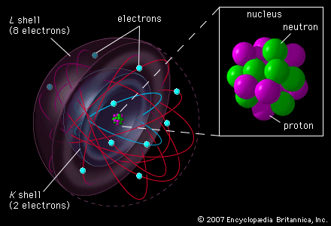

This is a Bohr’s model of an atom. You have the nucleus in the center of the atom which is blown up on the side. In the nucleus are neutrons and protons. Then there are electrons around the nucleus in some type of orbitals. But Bohr’s model of the atom does not make sense. Briefly the electrons would radiate off all of their energy in a short time and the atomic structure would disintegrate. In addition there are some questions of what the atomic structure really looks like. We do know that there are electrons and protons in the atoms and there is a nucleus with protons and neutrons in it. However, the nucleus is very small. Let me give you some examples. Atoms are largely empty space of small bodies of matter surrounded by large electromagnetic fields. This diagram of the atom is really disproportionate. As an example, if the nucleus of an atom is a basketball in Washington D.C., then the electrons would be baseballs in New York City two hundred miles away. The rest of the atom is empty space.

The only thing that gives the atom bulk are electromagnetic fields. When I push my two fingers together, I am not pushing matter against matter, I am just pushing two electromagnetic fields against each other. It is like trying to push together two magnets of the same polarity-two positives together or two negatives together. The two magnets push each other apart. For instance, if you took all of the atoms in my body and stripped them of their electromagnetic fields, you would not even see me. I would just be a dot. I would not even be a dot on the head of a pin. It is estimated by some physicists that all the matter in the universe with its electrons and protons stripped of their electromagnetic fields would only be a ball about our radius around the sun. That ball is all the matter in the universe with an equal number of electrons and protons stripped them of their electromagnetic fields from 400 billion galaxies of 100 billion stars each. That is all the matter in the universe! The matter of the universe is just puffed up with the electromagnetic fields of its electrons and protons. The only reason you see matter and we ourselves are not invisible is that the electrons in atoms give off light from all over the atom.

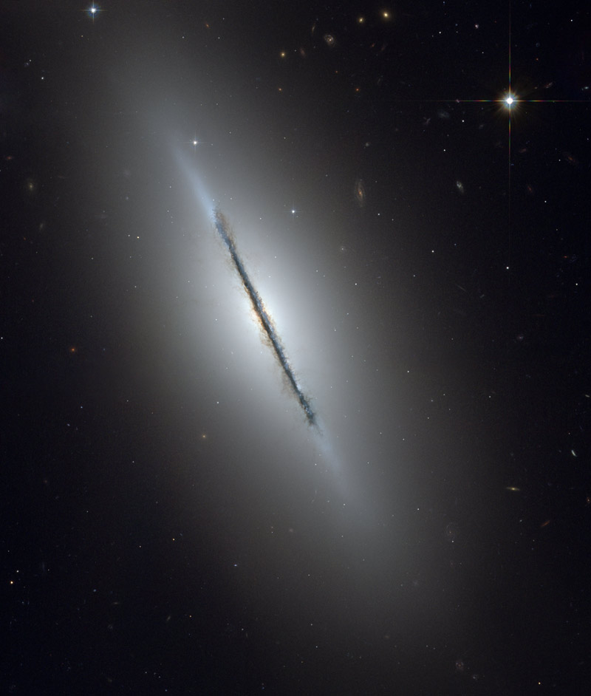

This is a photo of a single galaxy. Galaxies are large bodies of matter and energy, generally containing a hundred billion stars.
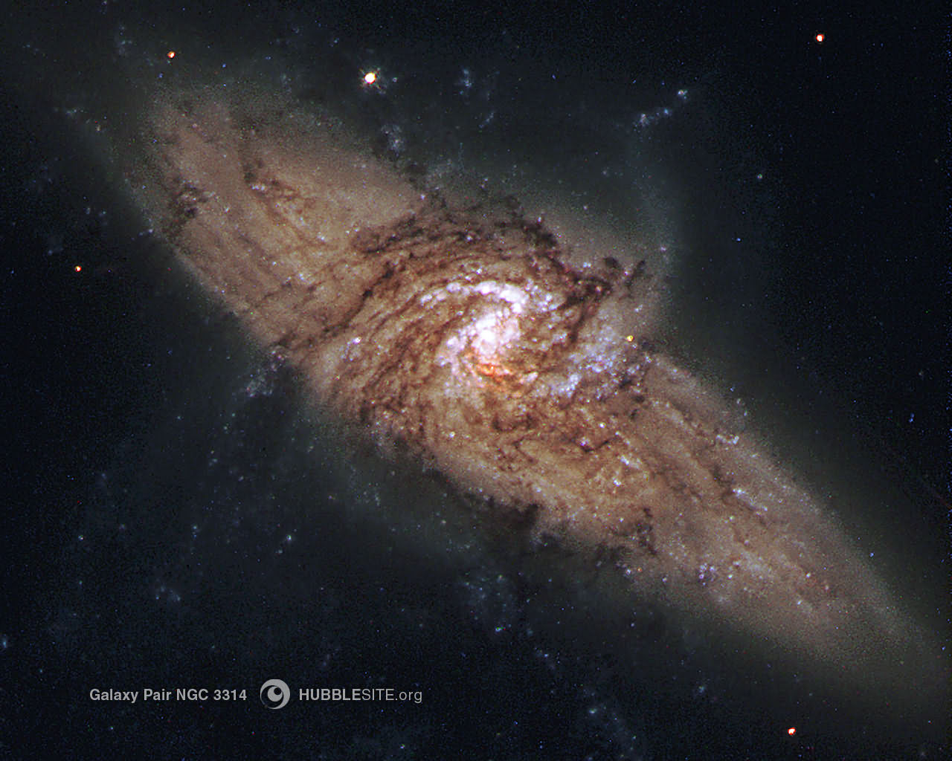

This is an interesting case of two galaxies. See the galaxy in the foreground. It is evidently flat and turned up on its edge so that we are looking down on this galaxy in the foreground. There is another galaxy behind this foreground galaxy. The background galaxy is at a flatter angle and is shining its light through the first foreground galaxy. The light from the background galaxy silhouettes the foreground galaxy like an x-ray. We can see the structure of the foreground galaxy with the light shining through it from the second, background galaxy.

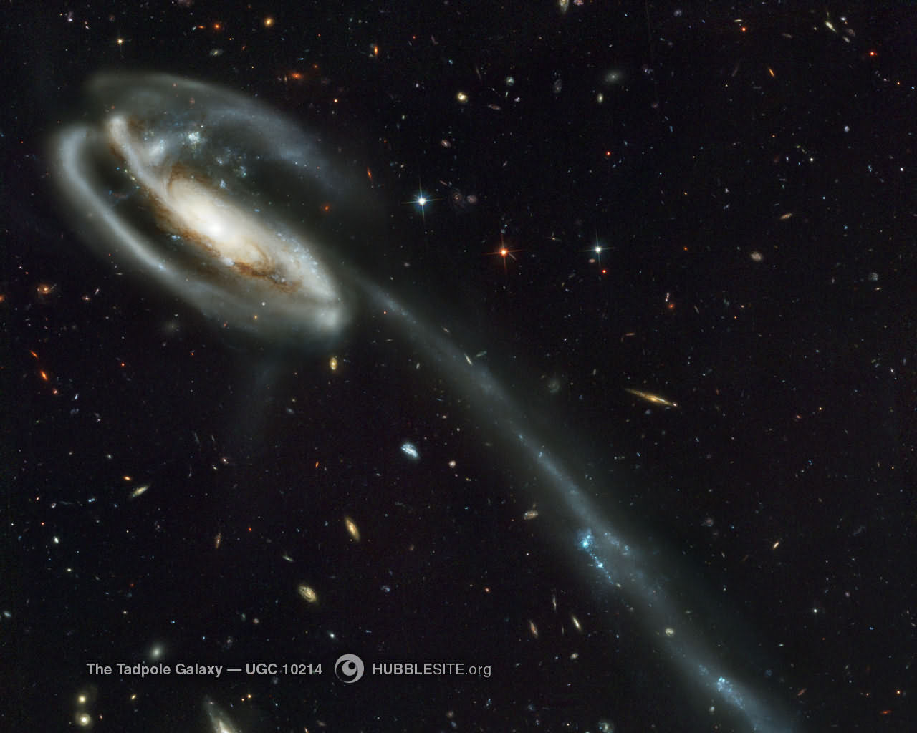

This is a galaxy like all other galaxies, its giving off its matter and energy into disorder to be spread throughout the universe. See it spinning? It is spinning a little too fast and it is throwing its stars out into space. This galaxy is even forming into a double helix as it spins. So this galaxy by spinning too fast is destroying itself. This galaxy doing exactly as the second law would say-it is giving off its matter and its energy never to get it back again. We would never see this galaxy if it were not giving off light energy into space. Our own sun as a star is giving off tremendous amounts of energy every second that it will never get back.

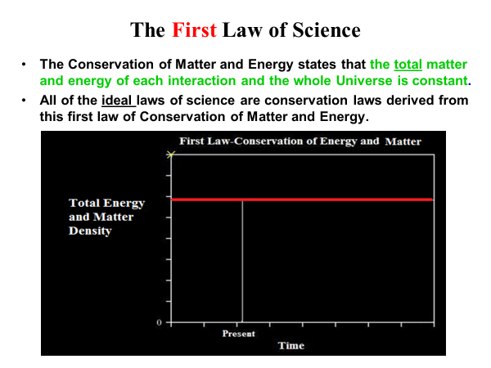

Let us look at a graph of the first law. The first law states that the total matter and energy of each interaction of the whole universe is constant. All the ideal laws of science are conservation laws and they are derived from this first law. Time in this graph is in the horizontal direction. The total amount of energy and matter or energy/energy density in the universe is in vertical direction of the graph. The total matter and energy of the universe is a straight line for all time. The quantity of matter and energy in the universe does not change with time. The universe at the present time has the same amount of matter and energy that it had a thousand years ago and will have a thousand years from now.

Why is the first law true? As we look back in Genesis, "In the beginning God created the heavens and the earth." "God blessed the seventh day (he created six days and he blessed the seventh day) and sanctified it, because in it He rested from His works which God had created." In a parallel passage from the New Testament, talking about Christ as the Creator, the book of John says, "All things were made through Him, and without Him nothing was made that was made." This is a stunning statement. This is a person who walked the earth and yet He has the powers to create the whole universe. Christ demonstrated by His miracles in the book of John that He is the Creator of the universe. The apostle John chose those miracles to demonstrate that Christ is the Creator of the universe. Jesus’ miracles in the book of John are all violations of these laws of science, very violent violations. Christ is not like a prophet.

Christ simply spoke to the wind and it obeyed His command. For instance He spoke to the wind and waves of a violent storm on the sea, "Be calm." He did not have to pray to ask God to calm the storm. As the Creator of the universe, He has command over the wind and waves. His command to calm the sea and wind absorbed all the energy out of that storm. His command was not just to stop the wind. His command ate up all the energy of the waves. He walked with His feet on the waves in a big storm without sinking. No one can walk on water. There is not enough flotation in a person’s feet to do that. No human can take water and turn it to wine. No human can do those things but Christ as the Creator had those powers.

But returning to the creation of the universe in Genesis, since the sixth day of creation, there has been no new matter or no new energy created or destroyed according to this first law of science. The cessation of the creation of matter and energy on the sixth day of creation is the origin of this law of science. This first law of science is the law of creation, an historical event in Genesis 1 and 2. Why this is so interesting, God has a sense of humor. But it is not necessarily a laughing sense of humor-it is one of sarcasm in a sense. Almost all of the scientists say, "Oh there's no value in the first part of Genesis, none of it is historically or scientifically correct." But God has buried the very two laws on which we build all of our science in Genesis 1-3. Since the sixth day of creation, the universe can not create one gram of matter or destroy it, or one joule of energy and destroy it. That's where this first law comes from.

The second law is called the law of Increasing Entropy. We always use big words in science to bedazzle the uninitiated non-scientists and neophytes. Entropy means simply disorder. This second law of increasing disorder/entropy states that matter and energy always loses quality, that is usefulness or order, in every interaction, this is according to the 19th century physicist Boltzmann. He was unbelievable for the 1800s, he developed this law which capsulized entropy as a probability. The first law is like an accountant, as I mentioned, that balances the books so that the quantity of matter and energy always remains the same in matter-energy interactions. The second law is like the manager, which always requires that matter and energy becomes disordered in matter-energy interactions.
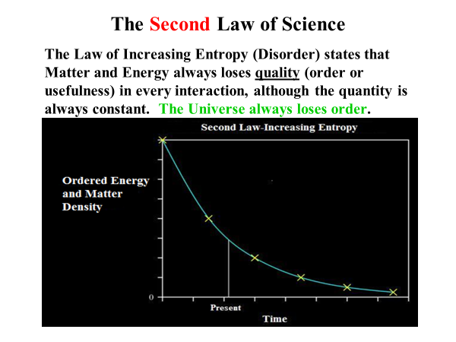

The second law can be graphed as the ordered or useful matter and energy in the universe as a function of time. The ordered/useful matter and energy in the universe will decrease with the passing of each moment of time. Yesterday, the universe had more ordered/useful matter and energy than today and tomorrow the universe will have less ordered/useful matter and energy than today.

Why is the second law true? "Cursed is the ground for your sake (This is in Genesis 3)... In the sweat of your face you shall eat bread till you return to the ground, for out of it you were taken for dust you are and to dust you shall return." At the gravesite of a funeral, the officiators will generally say: “dust to dust, and ashes to ashes.” We return to where we came from, the earth. "For the creation was subjected (this is in Romans 8) was subjected (that's in the past tense) to futility (in other words, this law of entropy), not willingly (nature didn't want to be that way), but because of Him (we're talking about God) who subjected it in hope; because the creation itself also will be delivered (in the future tense) from the bondage of corruption into the glorious liberty of the children of God. For we know that the whole creation groans and labors (at the present time nature groans and travails) with birth pangs together until now." The physical realm looking forward to that day it will be released from this bondage of corruption. The second law is the law of the fall and the curse-an historical event again in Genesis 3.

So, we have the origin of these two scientific laws drawn out of two historical events in the past. The second law allows for limited formations of order, such as simple structures in perfect crystals, we can never get a perfect crystal. Implications of the two laws: First law is where this professor started to come unglued and we are going to see why when we graph the two laws. The first law states that the universe cannot naturally create or destroy one gram of matter nor can it naturally create or destroy one joule of energy. Nature change its essential substance-matter and energy. Satan in the Garden of Eden was right in that sense-what you've got is what you've got, its not going to change in quantity. In other words, the material universe can not increase or decrease itself.

This inability of the universe to create or destroy itself naturally leaves only two conclusions. First, the universe is eternal-matter and energy have always been here. Or second, the universe was supernaturally created out of nothing by a supernatural agent external to the universe because there is nothing natural in the universe that can create matter. These are the only two choices: (1) the universe has always been here or (2) the universe was brought into being supernaturally. That is the conclusion according to this first law of science.

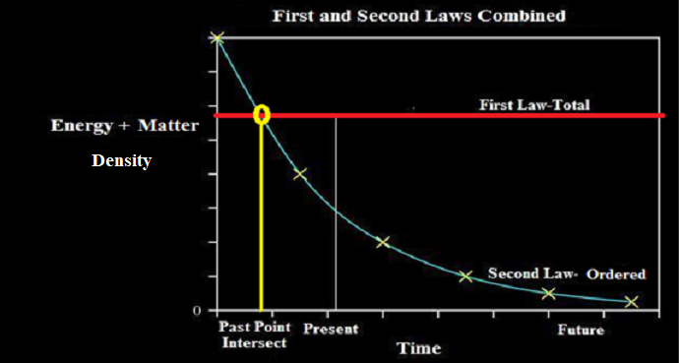

Let's graph these two laws. The two previous graphs of the first and laws are overlaid in this graph. Time in the horizontal direction and matter and energy are in the vertical direction. The present time is marked on the graph with the future to the right and the past to the right. The first law shows that the total amount of matter and energy is constant with time. Now coming from the past, the useful amount of energy and mass declines until we come to the present time. The universe has used up a certain amount of its ordered/useful matter and energy and the universe has so much ordered and useful energy left. This rate of loss of ordered matter and energy in the universe is an exponential decay-the universe loses half its ordered matter and energy value over uniform, equal periods of time. However, science do not know what the rate of exponential decay is for the universe. We do not know how fast the stars in the universe are burning out. We see them blowing up already so that we know that the stars and the universe are terminal. We see the terminal explosions of stars (novas and supernovas) on a regular basis, novas probably every 2 or 3 days and supernovas every once every year or two years.

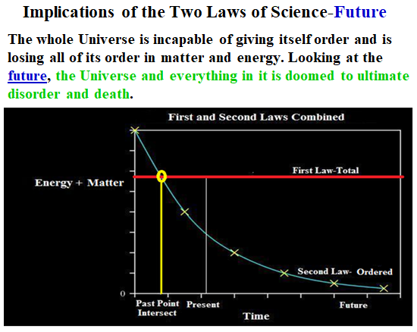

Now, let us look into the future of the matter and energy in the universe. What is going to happen to the universe in the future? The whole universe will lose all of its order in matter and energy in the future. The universe and everything in it is doomed to what? Ultimate disorder and death. That is where the universe is headed when all of its stars and its celestial bodies will have lost all of the ordered energy into deep space. Right now, it is estimated that the temperature in deep space is about 2.7 degrees above absolute zero temperature. It is estimated that when all the stars are burned out, the temperature of deep space will rise up to only four degrees above absolute zero. At this point all the energy of the universe will be uniformly spread out over deep space. Deep space will be an ocean of microwave energy at very low energy levels. That is where the universe will end up in the future according to the second law.
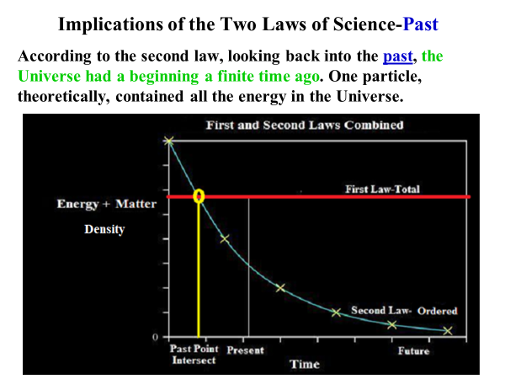

Now, let us go back to the past in this graph. According to the combination of the first and the second laws, looking back into the past the universe had a beginning a finite time ago. As we go back in time from the present, the universe has more and more useful energy as the graph is followed further and further into past. However, the graph comes to a point in the past where the useful energy equals the total energy of the universe. It is not possible to further back in time. The universe can not have more useful matter and energy than total matter and energy, can it? Of course not! The universe can not have more useful matter and energy than total matter and energy.

So what does this intersection of total matter/energy and ordered matter and energy of the universe at some point in the finite past since the universe can not have more useful energy before this point in time. First, as an option the universe could not have been in total chaos (no order in matter and energy) then jumped up to this highly level of order of matter and energy in the universe from which the universe began to decay. That is a flagrant violation of the second law and that is not possible option. Secondly, the universe can not have been in this super ordered state of matter and energy at the intersection on the graph in a perpetual state from eternity past without decaying down its ordered matter and energy. In this option the universe would have celestial bodies with super high temperatures but without these bodies giving off any energy. This absurd perpetual state of the universe would not only be a violation of the second law but also the universe would still be in that unchanging highly ordered state without effects of the second law which the universe is not today. Theoretically, at this intersection point where all of the matter and energy in the universe is ordered, one particle at this point in time contained all the energy in the universe and then its present decline to ultimate disorder and chaos at some time in the future.

So these two laws only leave the conclusion: the universe had a beginning a finite time ago. Einstein agreed with this and so does nearly everyone else who holds to the Big Bang theory or to a supernatural Creation. There was a beginning to the universe a finite time ago, the universe is not eternal. Non-supernaturalists have no explanation of the origin of the material universe which does not violate these two laws. And this is all science, that's why that physics professor became unglued because he could see where this thing was going: The two basic laws of science eliminate any naturalistic origins for our universe composed of matter and energy. A supernatural Creation of the universe is the only rational conclusion from the laws of science.

We are left with only one conclusion, that the universe was supernaturally created and ordered, not just created but is actually given order by an external agent a finite time ago. Now this is hard core physics. If any one says the contrary trying to give naturalistic explanations, you can say, "No this is physics. These are the most basic laws of science. What other options do you have according to these laws of physics?" Be very clear with them. “Give me some other options.” There are no naturalistic options which do not violate these basic laws of science. These laws forced us back to supernaturalism and a supernatural agent to bring the matter and energy of the universe into existence and then to give them order.

But let us take the implications of these two laws even further. The second law also requires that this external agent can not be part of the material universe because the material agent be dying and disordering with all of the rest of the universe. Take as an example the modern pantheists, the new age people. They believe there is a “Oneness”, a spirit in the universe. Do you know the trouble with that concept both scientifically, philosophically, and spiritually? That New Age “Oneness” is dying. The “Oneness” attached to nature and it is dying and crumbling with nature every day. There is also the “Force” of the New Age, as in the Star Wars films. The “Force” is also dying because it is inseparable from the material universe and it is trapped by entropy, being dragged down to its death by entropy. These pantheistic beliefs are a stupid idea philosophically and religiously, as well as being depressing nihilistic. However, this pantheistic spirituality is held by a large number of people and its coming back as a major religious system.

But what else does the second law require of this agent which brought the universe into being and gave it its order? The supernatural agent ordering the universe had to have more energy than the universe to give the universe its order. For instance, to create a star, like our sun, an agent would have to take all the energy the star has ever given off in its lifetime and to bring the energy back together in the star to its beginning point in time. That means that the agent would have to have more energy than the star gives off in all of its lifetime. For a supernatural agent to create the universe that agent must have more energy than the whole universe (all the stars, all the galaxies, 400 billion galaxies with 100 billion stars) in order to put the ordered universe together. In fact according to these laws, the supernatural agent would have to have more energy than all of the universe’s celestial systems give off in their lifetimes.

In addition, the supernatural agent who ordered the universe must be immaterial, not made of matter. The reason for this that the agent would have to travel faster than the speed of light in order to reach every part of the universe in a relatively short amount of time in order to give every part of the universe order. This agent, traveling at Einstein's speed of light, can not first start on one side of the universe and come over here at the center, ordering celestial systems as it went. The first part of the ordered universe would be dead before the agent gets to the center of the universe, even traveling at the speed of light as it order celestial systems on the way. By the time the agent gets to the opposite side of the universe, this center part of the universe will be dead. The agent has to travel faster than the speed of light to get all of universe to order the whole universe in a short amount of time. Or, some may at the Big Bang origin of the universe the matter and energy was not widely spread out so that a universe-ordering agent did not have to travel very far. However, in the Big Bang hypothesis the temperatures of the matter and energy of the universe are so high that no matter can exist either. Either the agent has to travel faster than the speed of light, which no matter can do, or it has to work in conditions that no matter can exist, it is too hot. So in either case of the vast universe or Big Bang theories, this universe-ordering agent cannot be made out of matter. The universe-ordering agent can not be natural but supernatural, not material in nature.

So science requires that the universe had to have an supernatural ordering agent that has more energy than the whole universe and that can not be made out of matter. Lastly, there is another characteristic of this supernatural agent that comes from information theory which is derived from the second law. Any system that is built must be built by an agent which is more complex than the system. For instance, the DNA required to fabricate a human has to be as complicated as a human or it will not produce a human. A watchmaker has to be smarter and more complex than the watch which he builds. Engineers to be smarter and more complex than the machines they build. In all cases, the second law requires that the agent that builds an ordered system has to be more complex than any part of the system it builds. In the case of the universe, that universe-ordering agent had to be more complex than man because man is the most complex part of the universe that we know. Some people believe in aliens, I do not. But in that case, the agent that organized the ordered universe has to be more complex than an alien.

According to these laws of science the agent that gave order to the universe had three characteristics: (1) has more energy than the whole universe, not to bring it into being but just order the universe, (2) has to be not made of matter and (3) has to be more complex than man. This supernatural agent can not be just a force, it has to have intelligence, will, and emotions of the complexity of man. An impersonal force will not satisfy these requirements, no matter how powerful. The only agent that I know of as a supernatural agent with these characteristics is a personal God. Only God with personality traits would fulfill these characteristics. These conclusions are all drawn from science by the way. We are not talking about philosophy, religion or anything else. These laws of science do not tell you when the beginning of the universe was and they do not tell you how it was done. These scientific laws tell you what the characteristics of the agent that brought the universe into being and gave the universe its order. And this is hard, cold science.

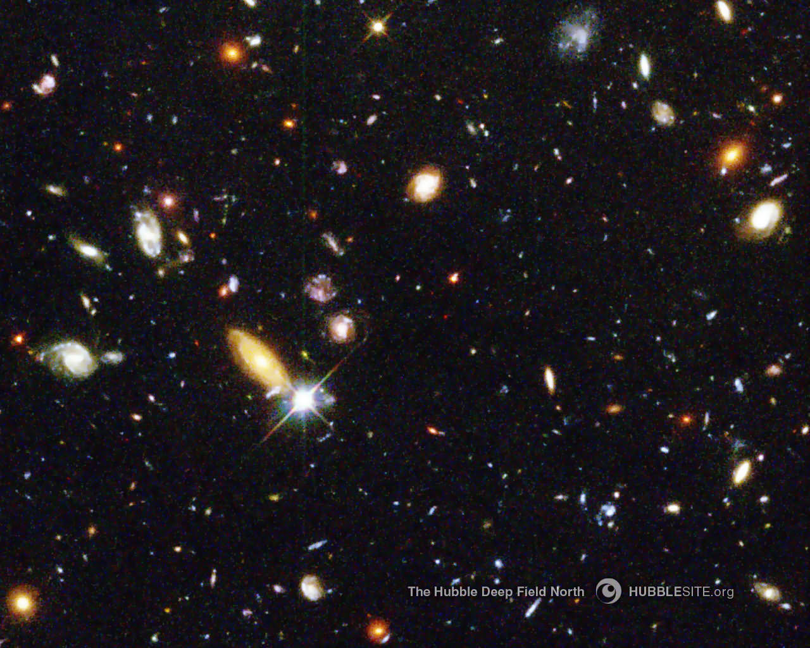

Look into the universe, this photo above is a deep field shot from the Hubble Telescope. These deep field photos are shot perpendicular to the plane of our galaxy, the Milky Way, to avoid light pollution from our galaxy and to focus deep into intergalactic space. In fact, this photo only caught one star in our galaxy. The rest of the celestial luminaries are galaxies. The Hubble telescope was turned up to full magnifying power for this photo. Look, these galaxies in the photo are disappearing into infinity. Interestingly, there is no way according to our known laws of physics that a Big Bang at the conception of the universe could blow those galaxies out to these distances, even traveling at the speed of light, and then send us light back. Traveling at Einstein’s speed of light it would take these galaxies more than 14 billion years to get to these positions in the Hubble photo and then another 14 billion years to send light back to us. These galaxies and their stars that supply the light in the photo are not eternal in time so their stellar fires would have died long ago. The space of the universe on the other hand appears to be infinite.

Naturalism is blindly antiscientific because it is Godless. They have no God to put what is known in science together in a scientific manner. The universe is mindless and godless in itself. The universe can not create itself together and it can not put itself together according to the laws of science. The two basic laws of science allow no possibility that the universe can create itself and no possibility that the universe can give itself order. The existing and ordered matter and energy of the Universe must have a supernatural Creator and Orderer who has all of the characteristics of God. Naturalism is blindly anti-scientific because naturalism is Godless.
Take the example of the watchmaker. If you see a watch, what do you know about that? You know that the watch did not happen by time and chance. Likewise, science concludes forensically that the highly ordered universe has a supernatural Creator. You can take the parts of a watch apart, then put the parts in a bag and shake them. Does it have energy? Yes. Is there enough energy to put the watch together? Yes? Will it happen? Well, you can figure out the probability, it won't happen in 20 billion years. But, if I take a watchmaker, give him sandwiches for an energy supply; he can put the watch together. In the case of naturalism, time and shaking to give the parts enough energy will not put the watch together. It takes an agent more complex than the system, the watchmaker, to put the watch together. So we conclude from science forensically that the universe had a supernatural Creator, not a naturalistic time and chance origin with some solar source for energy for shaking. The two laws of science mandate a supernatural Creator. Naturalism is antiscientific. Naturalism has no theory in the confines of the laws of science of naturally creating the universe and giving it order.

Let us look at destinies. You have the death of the universe in the future, and I have already mentioned that. The universe is dying, our stars are dying, life is dying, and there is no way to stop it. How do you stop the sun from burning itself out? How do you stop the stars from burning themselves out? You can not. They are dying an irreversible death. And once they are dead, they will never come back to life again.
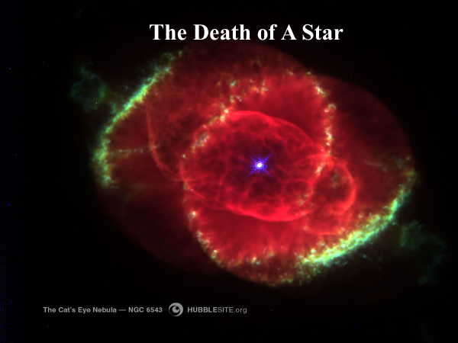

In the above photo we see the death of a star. The star blew up. This is all that is left of the star. The small bright blue dot is the core remains of the star and that residual core of the star will burn out. This star blew up and the core and the surrounding nebula are all that is left of the star. Almost all the nebula that we observe are products of stars blowing up-novas, explosions, or supernovas. And these explosions of stars do not happen very slowly. They happen in a matter of hours and often disappear in a matter of hours. In fact we can see light of an exploding star in the sky for several hours or days and then never see it again. All of a sudden there is a flash of the nova explosion of the star and then it disappears. We will never see the star again because it is too far away. We see these nova explosions of stars on a weekly basis and supernovas of big stars or star systems on a yearly basis.

What are the implications of the second law concerning the death of all life? The earth has lost 99% of all its species. We know that from the geological fossils. We are down to 1% of all the species which have ever existed. There are only 1 % still alive today. No new species are replacing those that have become extinct. Worse, the genetic material of the remaining 1% is degenerating. For instance each person has more genetic information than his or her children will have. Every person’s grandparents had more genetic material than the person has. The whole human race is losing their genome and its information, bit by bit, minute by minute, day by day. Even though we have 6 billion people, genetic gene pool is going down hill slowly. We have acquired in the last 100 years genetic defects across the whole human race that we have never had before such as the inability to simulate certain proteins and enzymes.

All life will disappear in our solar system and the universe. In fact, life will probably disappear from the earth long before the sun ever blows up. The second law of increasing entropy renders all human efforts in the world of matter and energy as transient and meaningless. In the mouth of Shakespeare's actor, I think it is in Macbeth, "Life is a tale told by an idiot, full of sound and fury and signifying nothing." That is from a purely materialist point of view. Life in the universe, according to T.S. Eliot, "ends not with a bang, but with a whimper." This is the reign of death in humans-death takes everyone down. There are only two humans in history that we know of that have not died are Enoch and Elijah.

There has only been one who died and then escaped permanently from the reign of death. That sole exception is the resurrection of Jesus Christ from the dead. It is the only known permanent violation of the scientific law of increasing entropy-the resurrection of Christ from the dead. "The wages of sin is death, but the free gift of God is eternal life in Jesus Christ our Lord." "But God demonstrates His love toward us, while we were yet sinners, Christ died for us." God, in the person of Jesus Christ, alone is able to save us from death and ultimate despair.

The above picture is titled "The creature needs his Creator." Christ destroyed death, the penalty of sin. The picture is of Michelangelo's painting on the ceiling of the Sistine Chapel in Rome. His painting is of the creation of man, the breathing of life into the man Adam by the touch of the Master’s hand. However, I have used the painting of the second birth of man, his spiritual birth to escape spiritual death. If you are tied to this life, even if you have a full life, you will die. It takes a second birth, a spiritual birth to escape the the second death, spiritual death after physical death.

Several years ago, I was invited to the University of Kansas to participate in a symposium. I got a telephone call and it was from this gal who said, "I represent the University of Kansas Society for the Open-minded Atheists and Agnostics.” I thought it was a joke at first. She continued, "We're going to have a panel discussion and we would like for you to represent Christianity. And I said, "Well what is the format of this symposium?" She said, “You will make a short presentation and questions will be asked from the audience.” And I said, "Well who is going to moderate this?" And she said, "One of the School of Religion professors." Knowing that the religion professors are agnostics, skeptics, and atheists, I thought to myself, "Oh yeah, this is really going to be good." Continuing, I said, "Who is going to be there on this panel?" And she said, "Well we will have a Wicca gal (a neo-pagan), a Muslim fellow, yourself, defending Christianity, a secular humanist (an atheist) and a Rabbi." In the questions and answers period, I said "I'm going to differentiate myself from most of these people. They are humanists. They believe that man is basically good and he is corrupted by society. I think that man is basically corrupt and he has corrupted society. It is the reverse of humanism."

Finally as we came down to the last question, this one fellow stood up and said, “I want each of you to give a rational basis what you believe." I knew this was coming because this is the bedrock question of atheists against theists. The Wicca girl gives her answer, the Muslim gives his, and then it came to me for a rational basis of Christianity. I said, "Basically I had a scientific education and entropy is the most powerful law we have in science. Entropy destroys our clothing, it destroys our universe and it is going to destroy all of us. Some of you are young beautiful girls. You'll become less beautiful, you'll become ugly, and then you'll die." All of the guys were laughing, so I said, "Don't laugh guys. Look at yourselves. My father was an all-American football player up here at the University of Kansas. Now, we push him around in a wheelchair and he doesn't have long for this world. Some of you are real bright people. I've known some real bright people. But, your ideas and your thoughts will end up in the dust of time and who will care? I know of only one exception to this law of entropy, and that's the resurrection of Christ from the dead. That is the rational basis for my faith."

The humanist atheist next to me was waiting to just to tear us all apart because there is no rational basis for belief in God in way of thinking. When I turned to him and said, “It is your turn,” he just staring off into space. He began repeating almost everything that I had said, "Yes it is true that the universe is going to be consumed by entropy. It is the scientific law of change and it is going to eat us all up. But somehow, somehow, we have to have courage and to live in the light of it." That was basically all he had to say.

